CENTRE FOR NANO AND SOFT MATTER SCIENCES
Prof. U.R. Rao Road, Jalahalli, BENGALURU 560 013.
Autonomous Institution under the Dept. of Science & Technology, Govt. of India

Extension of Last date for submission of Tender
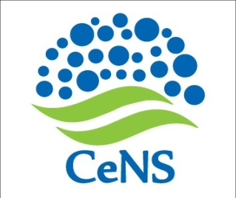

CeNS/2018-19/Admin- - Date: 11 January 2019

Subject: - Extension of due date for submission of Tender for the work of Construction of Amphi Theater at CeNS Campus Shivanapura

Ref:- CeNS/2018-19/Admin- Dated 03.01.2019

The last date for submission of tender for the above said work has been extended to Friday 18.01.19 by 3.0PM as 14.01.2019 in view of Makara sankranti/Pongal .

Sd/-
Administrative Officer

