CENTRE FOR NANO AND SOFT MATTER SCIENCES
Prof. U.R. Rao Road, Jalahalli, BENGALURU 560 013.
Autonomous Institution under the Dept. of Science & Technology, Govt. of India

CORRIGENDUM
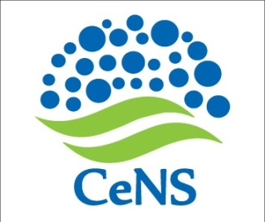

CeNS/2018-19/Admin-WO - Date: 09 January 2019

Name of work :- CONSTRUCTION OF AMPHI THEATER AT CeNS CAMPUS SHIVANAPURA

The EMD amount for the above said work (slno b) of notification CeNS/2018-19/Admin-WO dated 03 January 2019 may be read as Rs30,000/-(Thirty thousand) instead of Rs 30,0000/-

Yours sincerely

Sd/-
Administrative Officer

