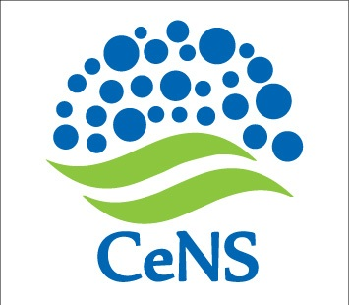No. CeNS/2016-17/RM/F1524.03.2017

# EXTENSION OF DUE DATE

**Ref:** Notice # : No. CeNS/2016-17/RM/F15 dated 15.03.2017

The last date for submission of Tender has been extended up to 17.00 hours of **28 March 2017**.

The form along with details can be downloaded from CeNS website [www.cens.res.in/Home/Tenders](http://www.cens.res.in/Home/Tenders).

sd/-

Administrative Officer

**CENTRE FOR NANO AND SOFT MATTER SCIENCES**

**Prof. U.R. Rao Road, Jalahalli, BENGALURU 560 013.**