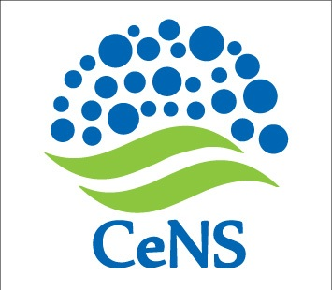
CENTRE FOR NANO AND SOFT MATTER SCIENCES
Prof. U.R. Rao Road, Jalahalli, BENGALURU 560 013.
Autonomous Institution under the Dept. of Science & Technology, Govt. of India

CORRIGENDUM TO TENDER NOTIFICATION
CeNS/2016-17/Land/EF-01-A
13 March 2017

The following points may be read in place of the existing contents in the Notification:

- Earnest Money Deposit: An amount of Rs. 50,000 (Fifty thousand only) may be remitted as Earnest Money Deposit instead of 5% of the total cost of the work.

- Enclosure of Demand Drafts: The Demand Drafts towards EMD and the Application Fee should be enclosed with the Technical bid cover (not techno-commercial bid, as indicated earlier).

Sd/-
Administrative Officer

