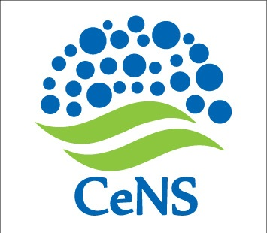No. CeNS/2016-17/Tender/Advt/Equip/00305.12.2016

**INVITATION TO TENDER**

# EXTENSION OF DUE DATE

**Ref:** Notice # : No. CeNS/2016-17/Tender/Advt/Equip/003 dated 18.11.2016

The last date for submission of Application form has been extended up to 17.00 hours of **08 December 2016**.

The form along with details can be downloaded from CeNS website [www.cens.res.in/Home/Tenders](http://www.cens.res.in/Home/Tenders).

sd/-

Administrative Officer

**CENTRE FOR NANO AND SOFT MATTER SCIENCES**

**Prof. U.R. Rao Road, Jalahalli, BENGALURU 560 013.**