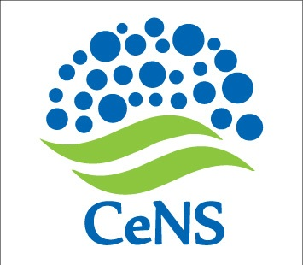**No.CeNS/2016-17/Civil/Advt.08 15.09.2016**

**PRE-QUALIFICATION OF CONTRACTORS**

# EXTENSION OF DUE DATE

**Ref:** Notice # : CeNS/2016-17/Civil/Advt.06 dated 31.08.2016

The last date for submission of Application form has been extended up to 17.00 hours of **20 September 2016**.

The form along with details can be downloaded from CeNS website [www.cens.res.in/Home/Tenders](http://www.cens.res.in/Home/Tenders).

sd/-

Administrative Officer

**CENTRE FOR NANO AND SOFT MATTER SCIENCES**

**Prof. U.R. Rao Road, Jalahalli, BENGALURU 560 013.**